**Programming Practice**

**Final Project Report**

Dept. of Computer Science & Engineering

2019-15049

SeungMin Lee

**1. How to build the project**

Put ‘2048.c’, ‘lib-cross.c’ and ‘lib-cross.h’ in same directory. Compile these codes with “gcc 2048.c lib-cross.c –o awesome2048”. Then run the project by “./awesome2048”.

**2. How to play the game**

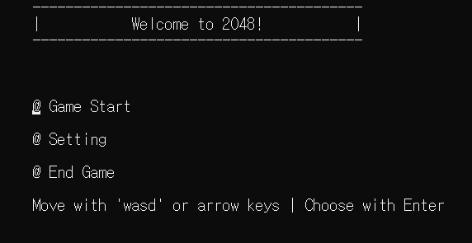**2.1. Main Menu**

You can move your cursor with ‘w’, ‘a’, ‘s’ or ‘d’ and also with ‘↑’, ’←’, ’↓’ or ‘→’. (Of course you can’t move your cursor with ‘a’, ‘d’, ’←’ or ‘→’ in main menu.)

You can choose menu by press Enter key.

**2.1.1. Game Start**

When you choose Game Start, you can play the 2048!

**2.1.2. Setting**

When you choose Setting, you can set your board size.

|  |  |
| --- | --- |
|  |  |

After you choose first menu(Change Board Size), you have to press number between 4 to 8. If you choose one of them, you can check your board size immediately.

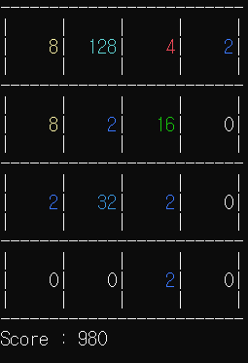**2.1.3. End Game**

Thank you for playing! The game will be closed.

**2.2. How to control in game & How to gain score**

It’s very simple! Same as main menu, you can play 2048 with ‘w’, ‘a’, ‘s’ or ‘d’ and also with ‘↑’, ’←’, ’↓’ or ‘→’.

Score will be increased when you merge your numbers! If you merge two 4s to 8, you can gain 8 points.

**2.3. Features I’ve created.**

**2.3.1. Non-optional**

* Moving and merging same numbers with each direction.
* Generating new numbers (Always 2) when move is successful.
* Check game over and game win(clear) state.
  + Game over when you can move your board anymore.
  + Game win when you create a 2048 tile.
* Calculate Score/Update Score

**2.3.2. Optional**

* Support 2048 with bigger board size (NxN, $4≤N≤8$). You can change board size in setting.
* More Screens (Main Menu / Setting)
* Colored Text
* Clear screen and redraw board for every key press
* Cute & Simple animation when game over or win!
* Adding additional key with moving board & choosing menu(‘↑’, ’←’, ’↓’ and ‘→’).